Name_____________________________________date_______________per___________

**6.5 Practice AB**

Describe the relationship between the two quantities.

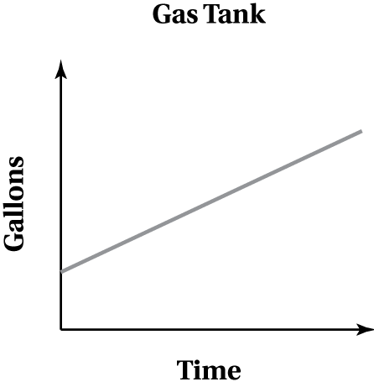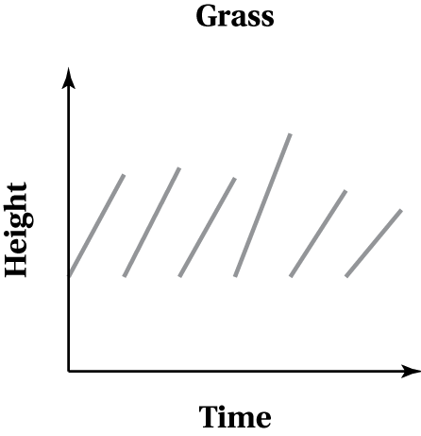 1. 2. 3. 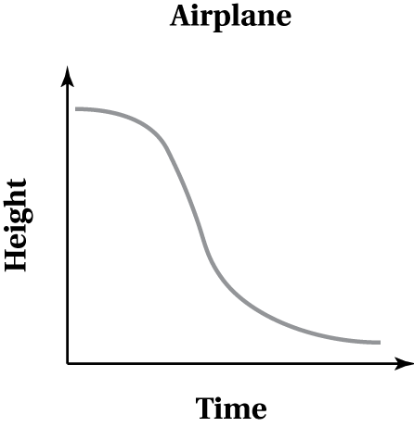

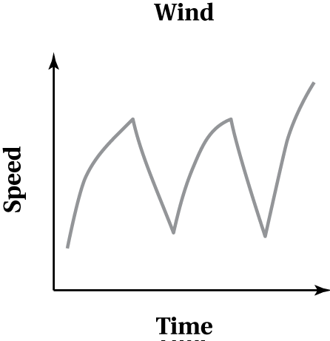4. 1) airplane__________________________________________________

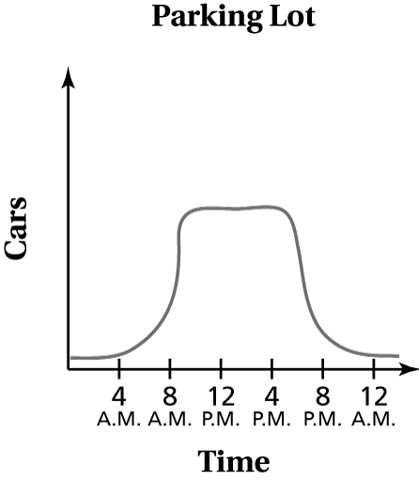5. **The graph shows the number of cars in the parking lot over a 24 hour period.**

a. **Describe the change in the number of cars from 7:00 a.m. to 9:00 a.m.**

b . **Describe the change in the number of cars from 5:00 p.m. to 7:00 p.m.**

Sketch a graph that represents a situation.

6. **The flu virus spreads quickly at first and then more slowly.**

7. **The sales of a new cell phone increase at an increasing rate, then the sales remain the same, and then the sales decrease at a constant rate.**

8. **The outside temperature decreased at a decreasing rate and then decreased at a constant rate.**

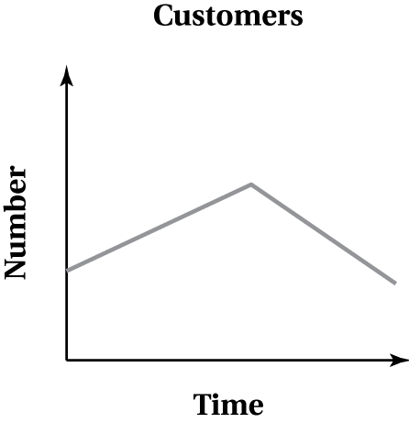**Describe the relationship between the two quantities**.

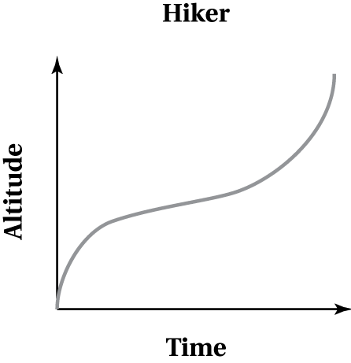 9. 10. 11. 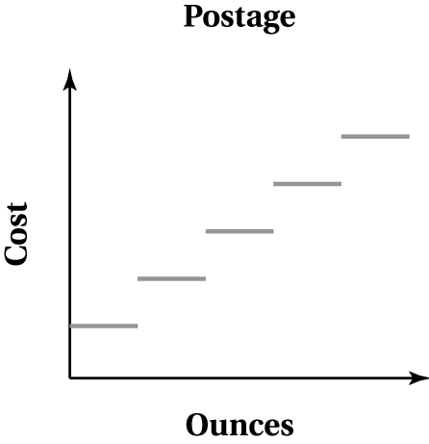

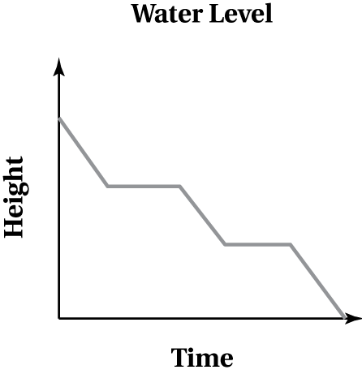12. 9) postage___________________________________________________

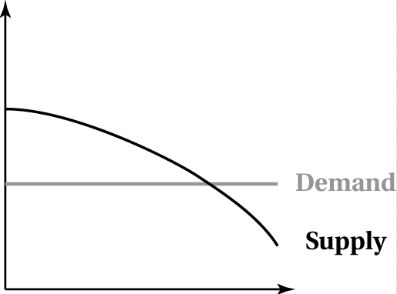 13. **The supply and demand model shows how the price of the shares of a new   
stock changes in a market.** a. **Describe and interpret each curve.**

b. **Which part of the graph represents a surplus? a shortage? Explain your reasoning.**

c. The curve intersects at the *equilibrium point*, which is where the number of shares equals the quantity demanded. Suppose that demand for the shares suddenly increases, causing the entire demand curve to shift up. What happens to the equilibrium point?